Phase 4: Create Transform Map

In this phase we need to create the Transform Map by clicking on the Create Transform Map button as shown in above screenshot.

Give inputs as shown below.
- Name: Sample Spreadsheet Import
- Source Table: Employee Import is auto-populated
- Target Table: Employee Test - as we created earlier

- Click on Auto Map Matching fields.

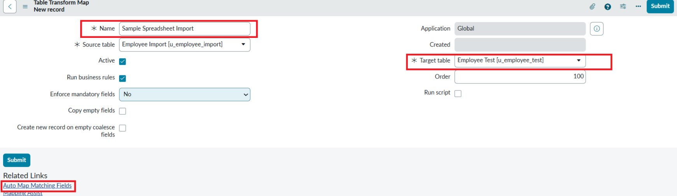

Now click on Mapping Assist and map the fields with Source & Target Table

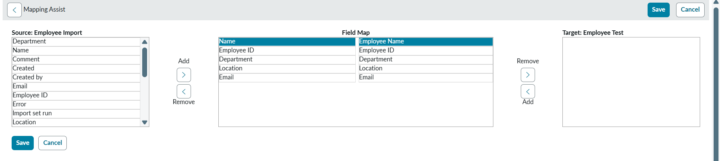

- Click on Save

Make sure the both Source & Target table fields are mapped as shown below.

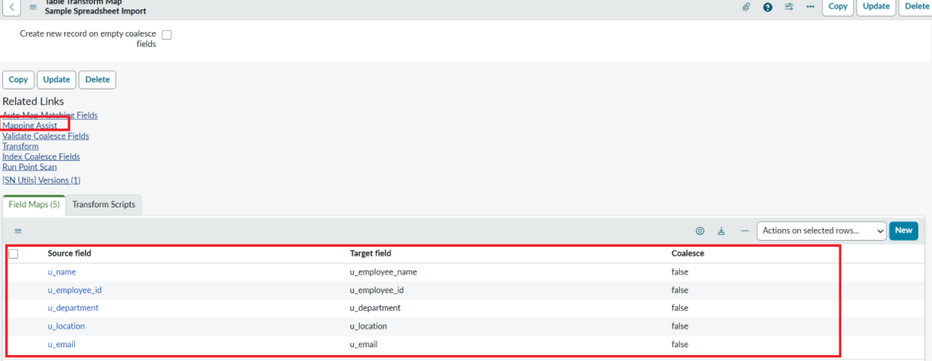

- Now click on Transform as shown below

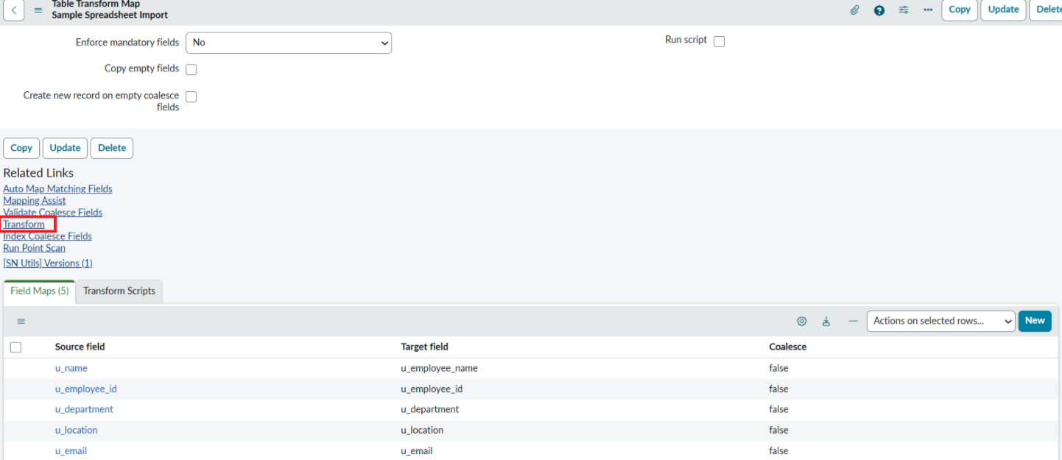

- Now click on Transform Button as shown below.

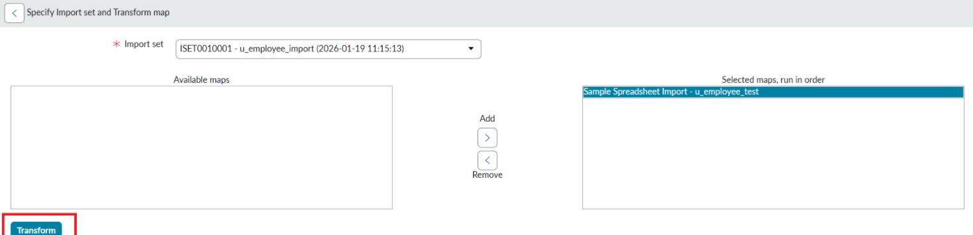

- After clicking Transform, make sure you see the success message as shown below.

